Part 1: Design Document

A. Scenario and Problem Definition

1. Describe a business problem that can be solved with a database solution and is in alignment with the chosen scenario.
EcoMart is an eco-conscious online marketplace that sells sustainable products across various categories. As the company grows, they face challenges in managing large volumes of product, sales, and customer data. Their current system lacks the flexibility and scalability needed to accommodate increasing data complexity and ensure reliable performance. EcoMart seeks a robust relational database to support product management, transaction tracking, and customer analytics, while also ensuring data security and compliance with privacy standards.
They also aim to incorporate new data elements such as product items, detailed descriptions, pricing, availability, sustainability certifications, and customer reviews.
2. Propose a data structure to solve the identified business problem.
To solve the business issue, I propose a relational database containing Country, Region, Products, Channel, Customer, Order and Review tables

3. Justify why a database solution will solve the identified business problem.
EcoMart deals with many types of data such as product, customers, regions and etc, and wants to build a database that is scalable and flexible for future changes with the incoming of new data. By building a relational database, we can ensure all data types are tables and at the same time connected to sales data table. It also enables to onboard more data in the future by simply adding more tables and creating a relationship via primary and foreign key between the tables. This also enables an easier way to track product details, order history, certifications and customer profiles.

4. Explain how the business data will be used within the database solution.
The business data will first undergo a cleaning process to ensure accuracy and consistency. After cleaning, the data will be organized into separate tables and saved as CSV files. These tables will then be created in pgAdmin to reflect the structure of the business model. Once the table structures are in place, the cleaned data will be imported into pgAdmin. In the Logical Data Model within pgAdmin, various tables will be displayed, each with defined primary and foreign keys to establish relationships between them.
By implementing the database, EcoMart will be able to centralize data from all areas of its business, enabling the team to input and manage information efficiently. This centralized system will provide a comprehensive view of operations globally, supporting deeper business insights through fast and targeted SQL queries. Tracking customer reviews will also help EcoMart identify and address product gaps, fostering continuous improvement. With simplified access to data, decision-making becomes faster and more informed. Furthermore, the centralized design supports business growth while maintaining data integrity and enabling the implementation of robust security measures to prevent data breaches.

B. Create a logical data model for storing data in the database solution.
Entities and relationships with Tables and Keys
- Region Table
  - Region_ID (PK)
  - Region_Name
- Country Table
  - Country_ID (PK)
  - Country_Name
  - Region_ID (FK)
- Products Table
  - Product_ID (PK)
  - Item_Type
  - Item_description
  - Unit_Price
  - Unit_Cost
  - Certification
  - Availability
- Channel Table
  - channel_ID (PK)
  - sales_channel
- Customer Table
  - Customer_ID (PK)
  - Customer_first_name
  - Customer_last_name
  - Customer_email
  - Cutomser_phone_number
- Customer Review Table
  - review_ID (PK)
  - product_ID (FK)
  - review_text
  - rating
  - review_date
- Order Table
  - Order_ID (PK)
  - Order_Date
  - Ship_Date
  - Country_ID (FK)
  - Product_ID (FK)
  - Channel_ID (FK)
  - Order_Priority
  - Units_Sold
  - Total_Revenue
  - Total_Cost
  - Total_Profit
  - Customer_ID (FK)
  - review_ID (FK)

- Region → Country = One-to-Many
- Country → Order = One-to-Many
- Product → Order = One-to-Many
- Customer → Order = One-to-Many
- Channel → Order = One-to-Many
- Product → Review = One-to-Many

C. Describe the database objects and storage, identifying the file attributes within the database solution.
Keys help define relationships and ensure referential integrity.
- Primary Keys (PK): Uniquely identify each record in a table.
  - Examples: Region_ID, Country_ID, Product_ID, Order_ID, Customer_ID, Review_ID, Channel_ID
- Foreign Keys (FK): Establish relationships between tables.
  - Examples:
    - Region_ID in Country links to Region
    - Product_ID, Country_ID, Customer_ID, Channel_ID, Review_ID in Order link to corresponding tables
    - Product_ID in Customer_Review links to Products
- Region → Country (One-to-Many): Each region can have multiple countries
- Country → Order (One-to-Many): Orders are placed by customers in different countries
- Product → Order (One-to-Many): One product can appear in many orders
- Customer → Order (One-to-Many): A customer can place multiple orders
- Channel → Order (One-to-Many): Orders can come through various sales channels
- Product → Review (One-to-Many): Each product can have multiple reviews
The columns from file are mapped directly to attributes in our tables as per the data model.

D. Discuss how the proposed database design addresses scalability concerns, including strategies that align with the chosen scenario.
The proposed relational database design for EcoMart is built with scalability in mind to support the company’s rapid growth, evolving product catalog, and increasing customer base. It uses a normalized modular structure, to avoid redundancy by storing data in related, normalized tables that separates data into logical tables—such as Products, Order, Customers, and Country—allowing for efficient data expansion and easy maintenance without disrupting existing structures. Strategic indexing on frequently queried columns can also be added to speeds up data retrieval. Large transactional tables can be partitioned by date or region to improve performance.

E. Outline the privacy and security measures that should be implemented in the proposed database design.

Security Implementation
- Grant read/write/admin roles based on user need within each table
- Mask sensitive fields: For Customer Personal data, create column encryptions and prevent accessibility.
- Schedule auto backups to prevent data loss for any future reason.

- Part 2: Implementation

  - Create a database:
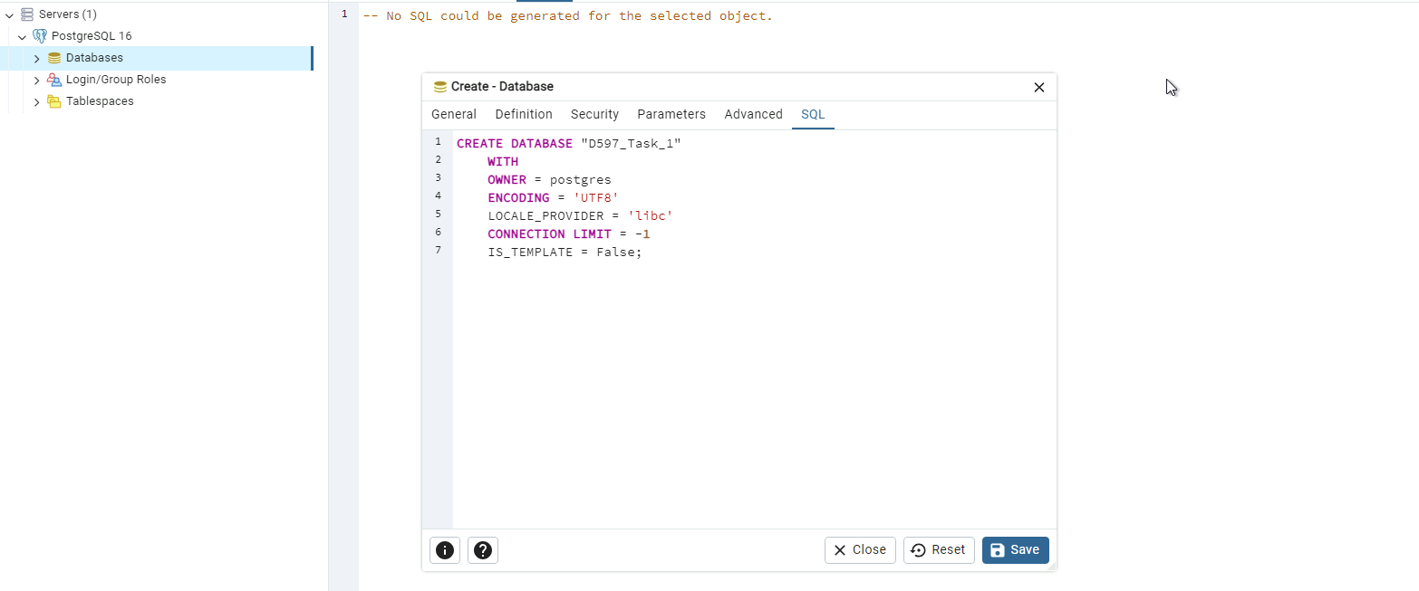
  - Create tables and import CVS files
Please note there is no Script to import data into PgAdmin (B. Data Import). It’s a feature enabled to add CSV file.
Step 1:
- Table and Column Script | - Data Import | - Data view
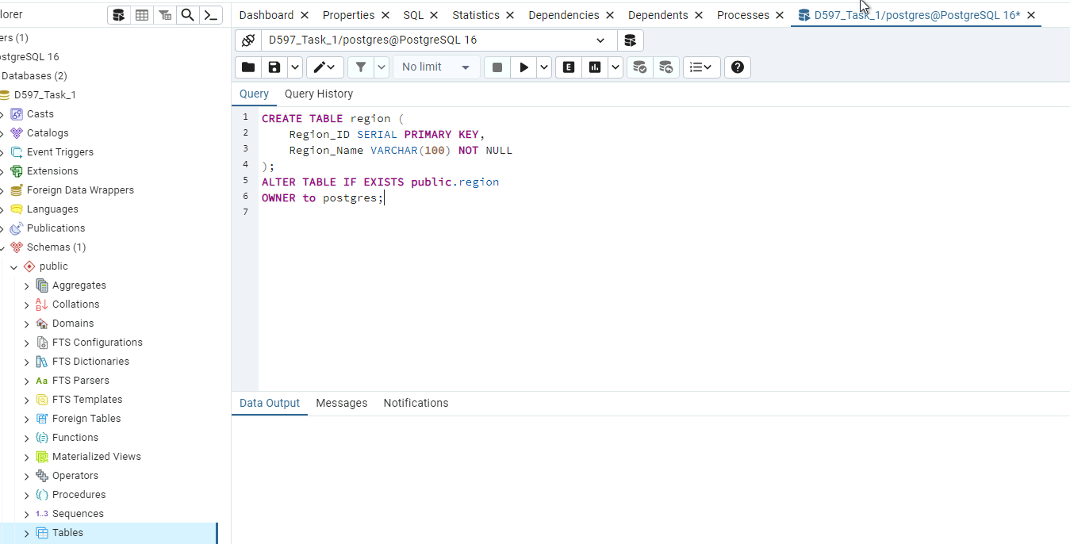 | 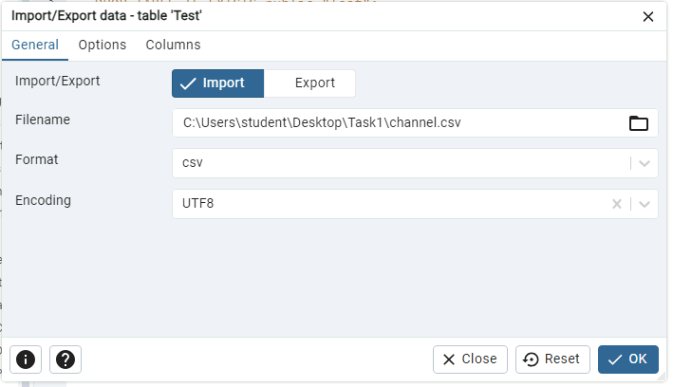 | 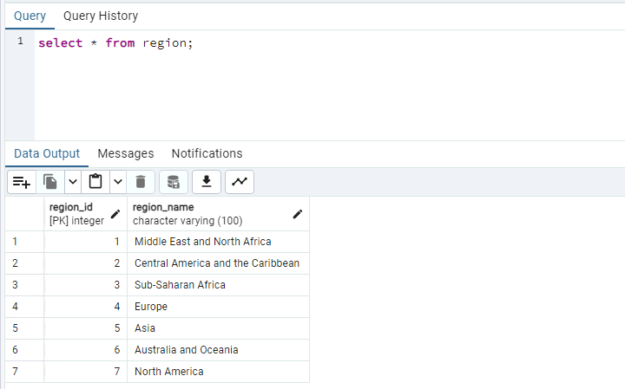

Step 2:
- Table and Column Script | - Data Import | - Data view
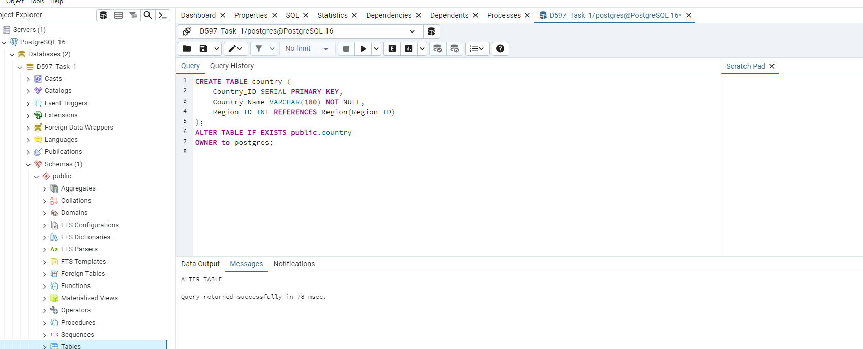 | 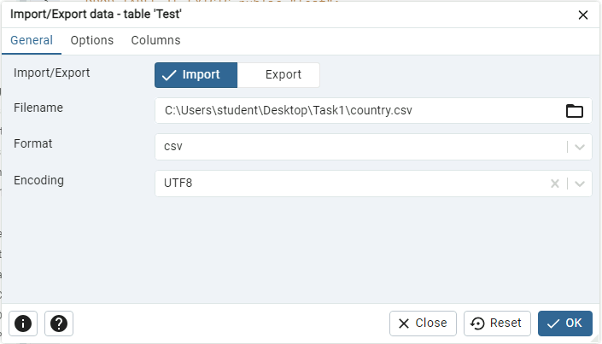 | 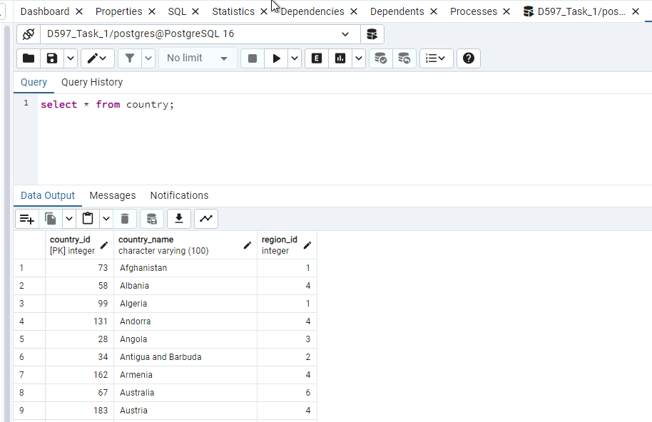

Step 3:
- Table and Column Script | - Data Import | - Data view
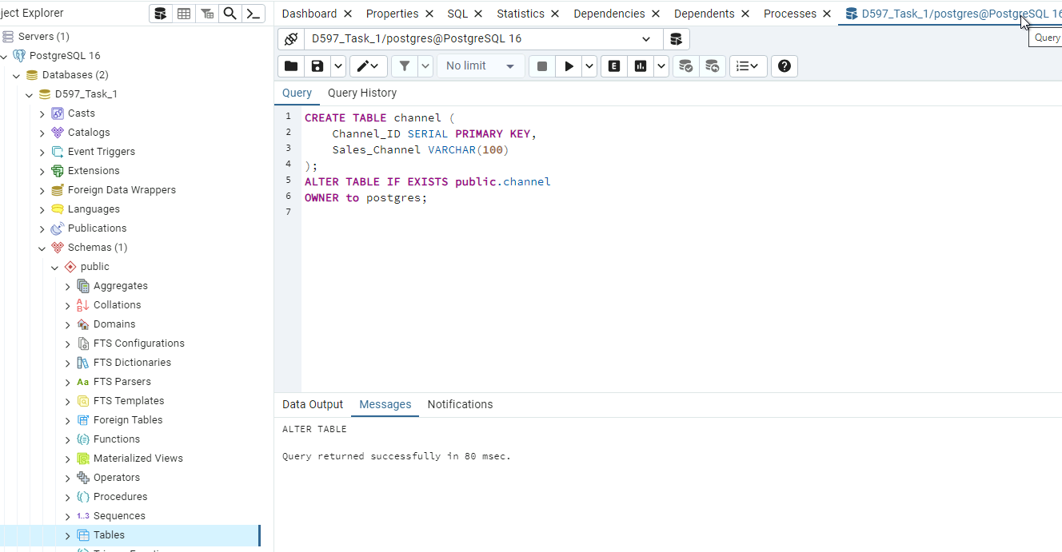 | 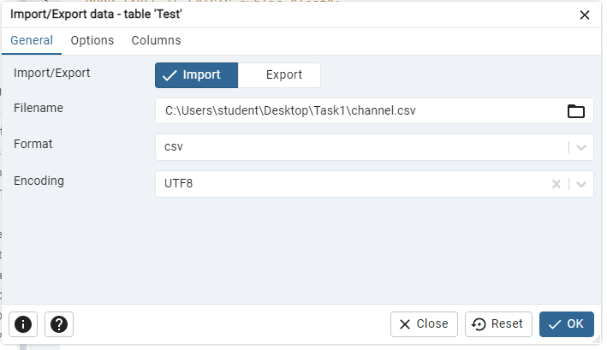 | 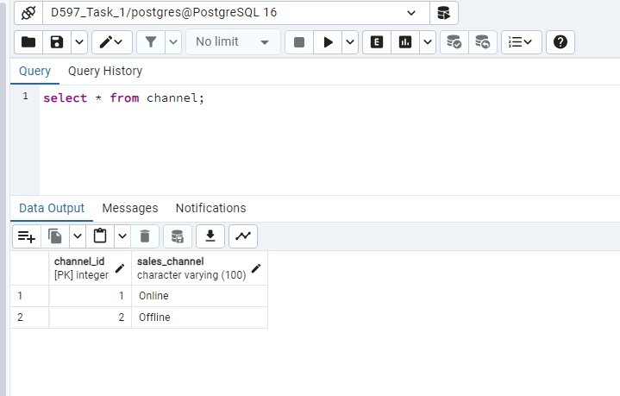

Step 4:
- Table and Column Script | - Data Import | - Data view
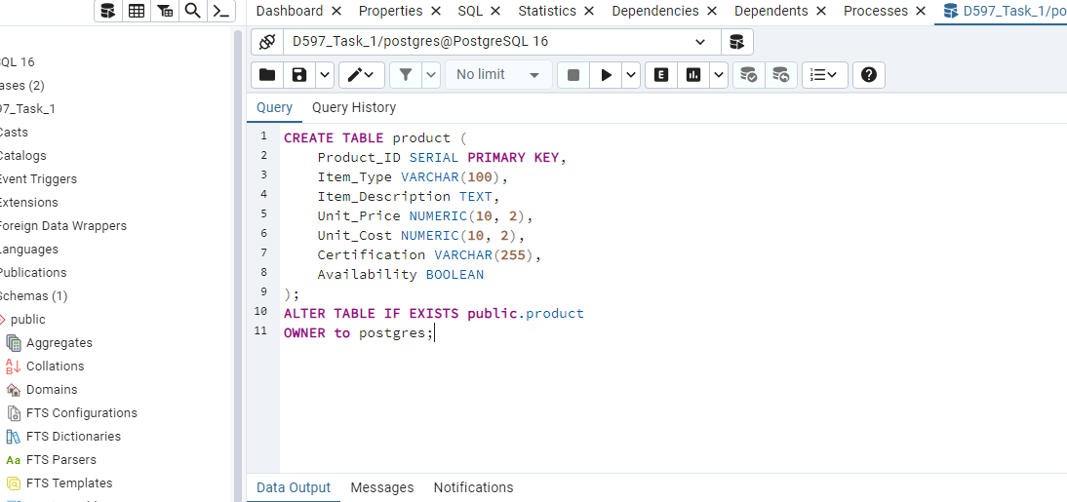 | 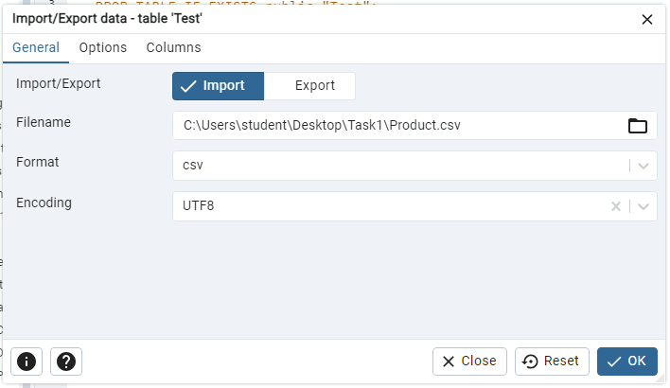 | 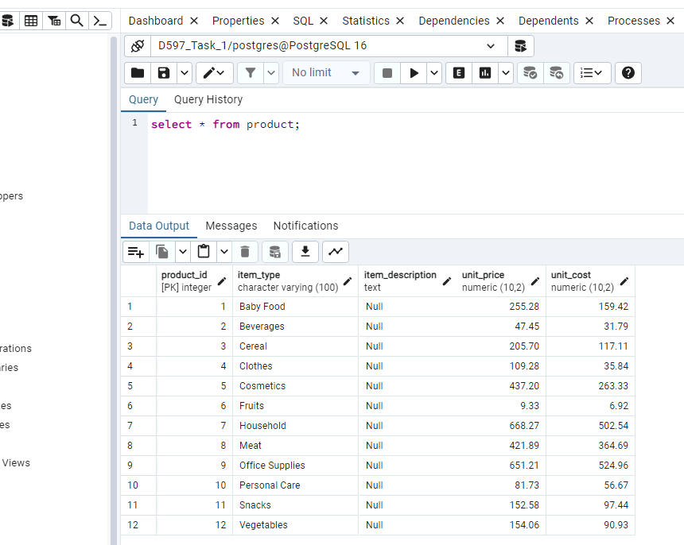

Step 5:
- Table and Column Script | - Data Import | - Data view
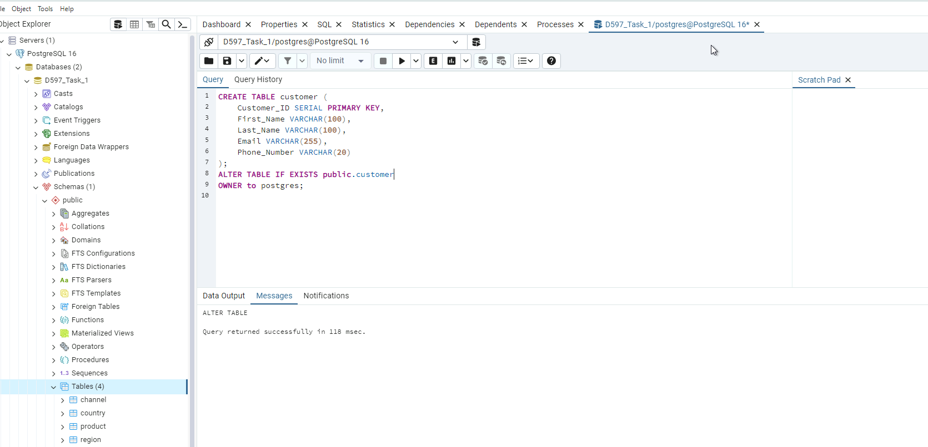 | No data is being imported, as this is a newly created table designed to meet client requirements. | 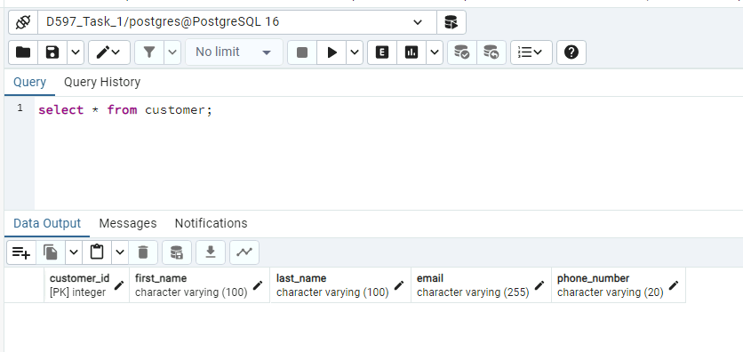

Step 6:
- Table and Column Script | - Data Import | - Data view
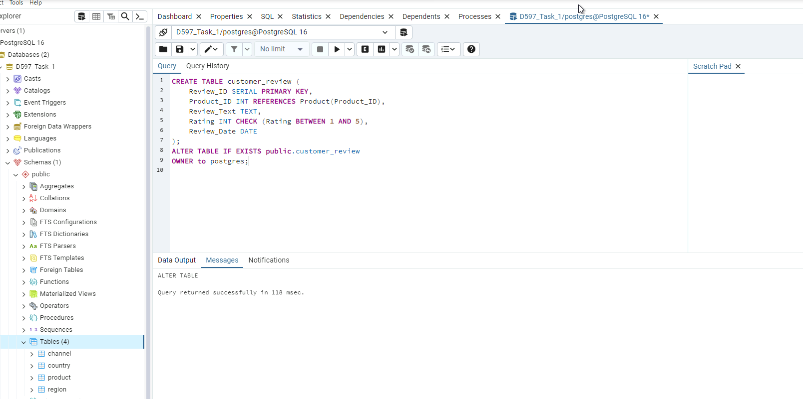 | No data is being imported, as this is a newly created table designed to meet client requirements. | 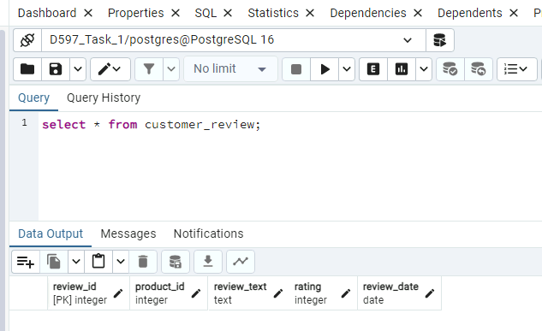

Step 7:
- Table and Column Script | - Data Import | - Data view
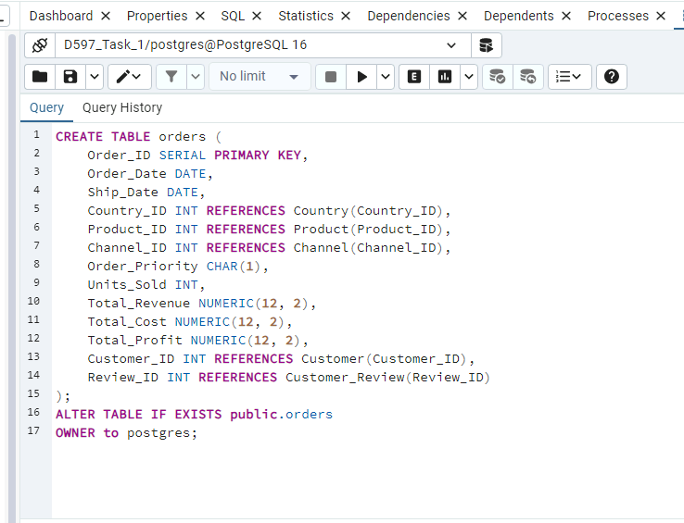 | 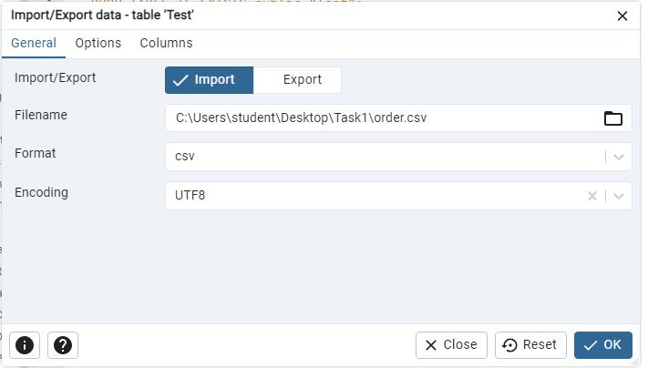 | 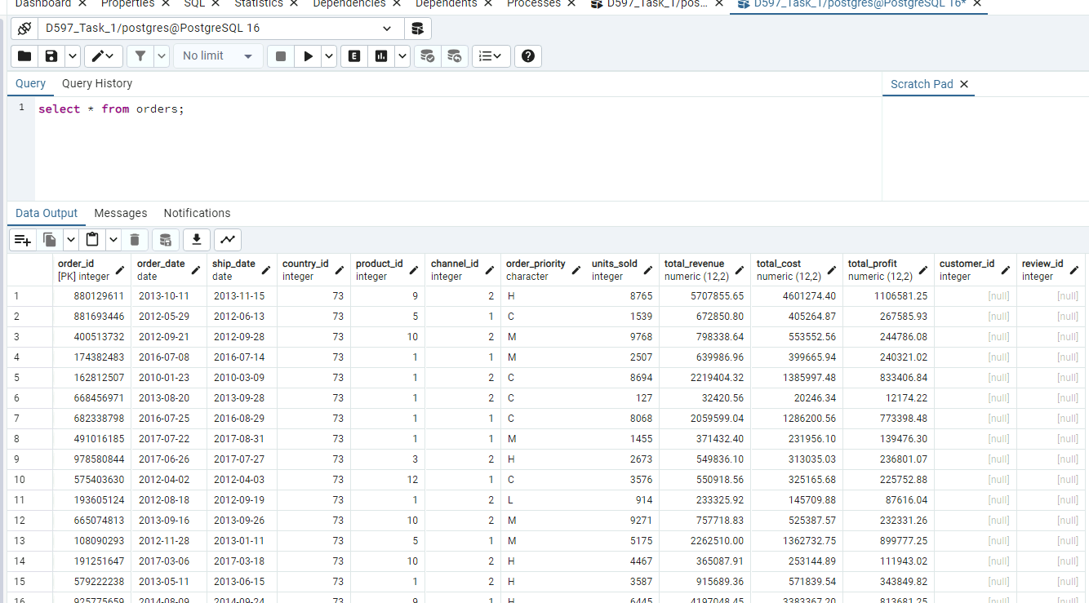

Script + Optimization
Example 1:
Script 1 (run time on bottom screenshot) | 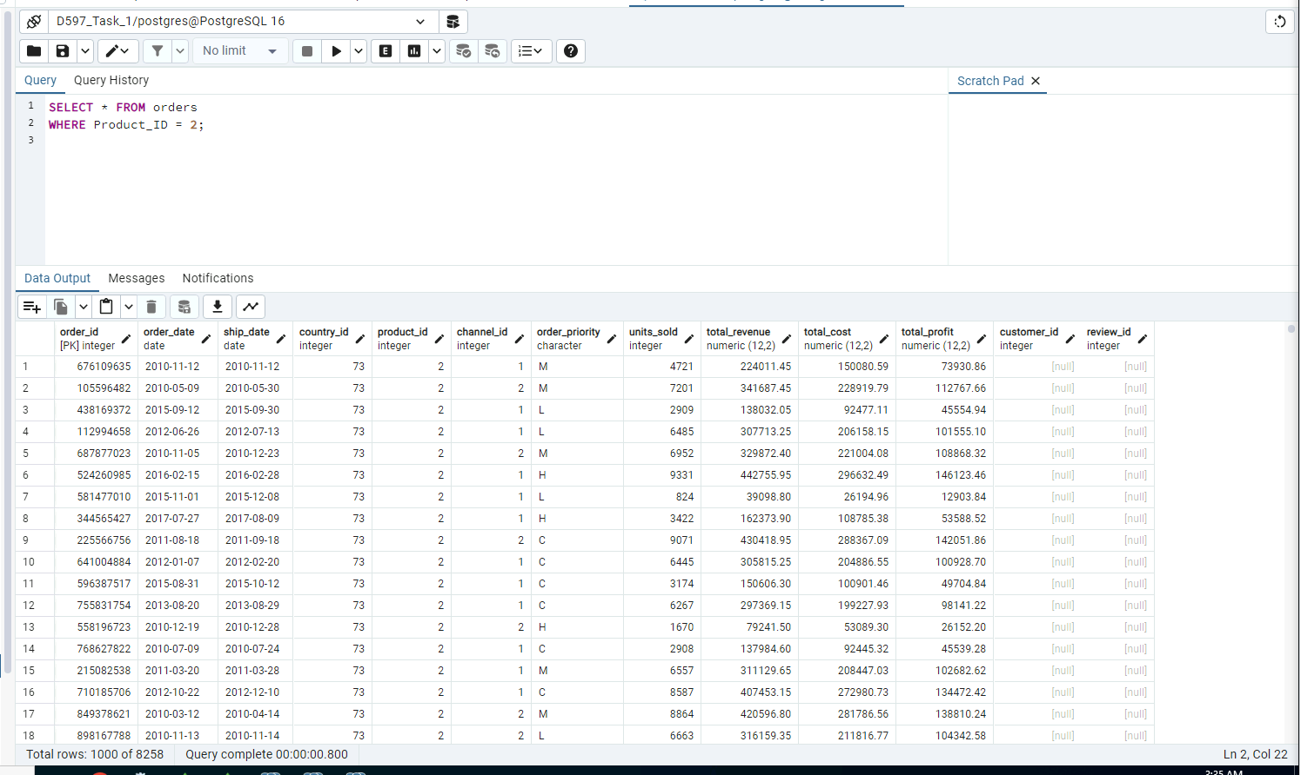
Script 1 Index | 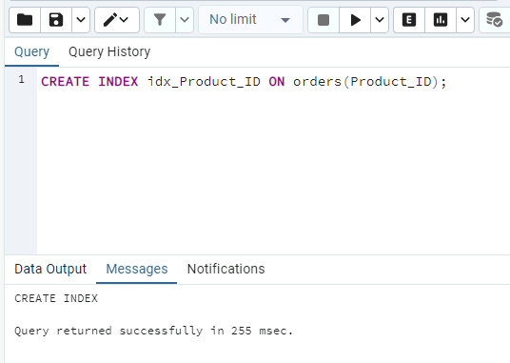
Script 1 with optimization (run time on bottom screenshot) | 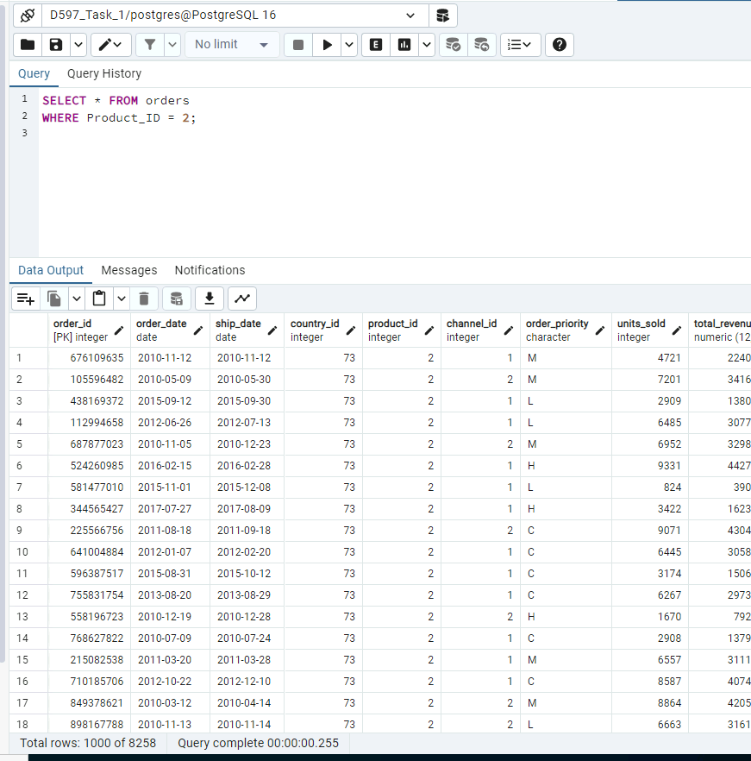

Example 2:
Script 2 (run time on bottom screenshot) | 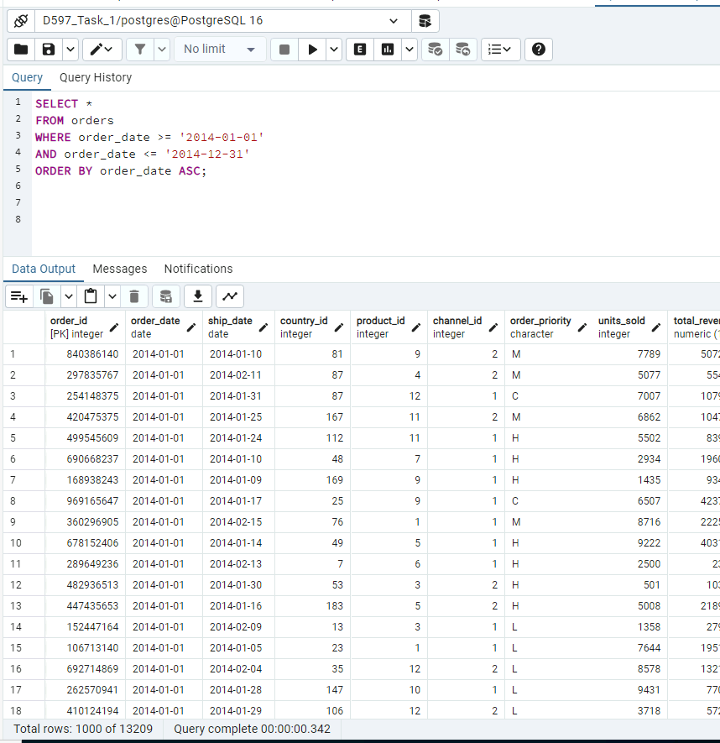
Script 2 Index | 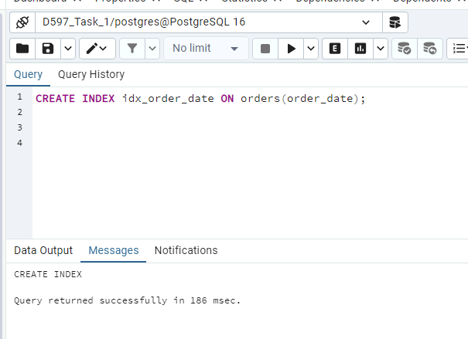
Script 2 with optimization (run time on bottom screenshot) | 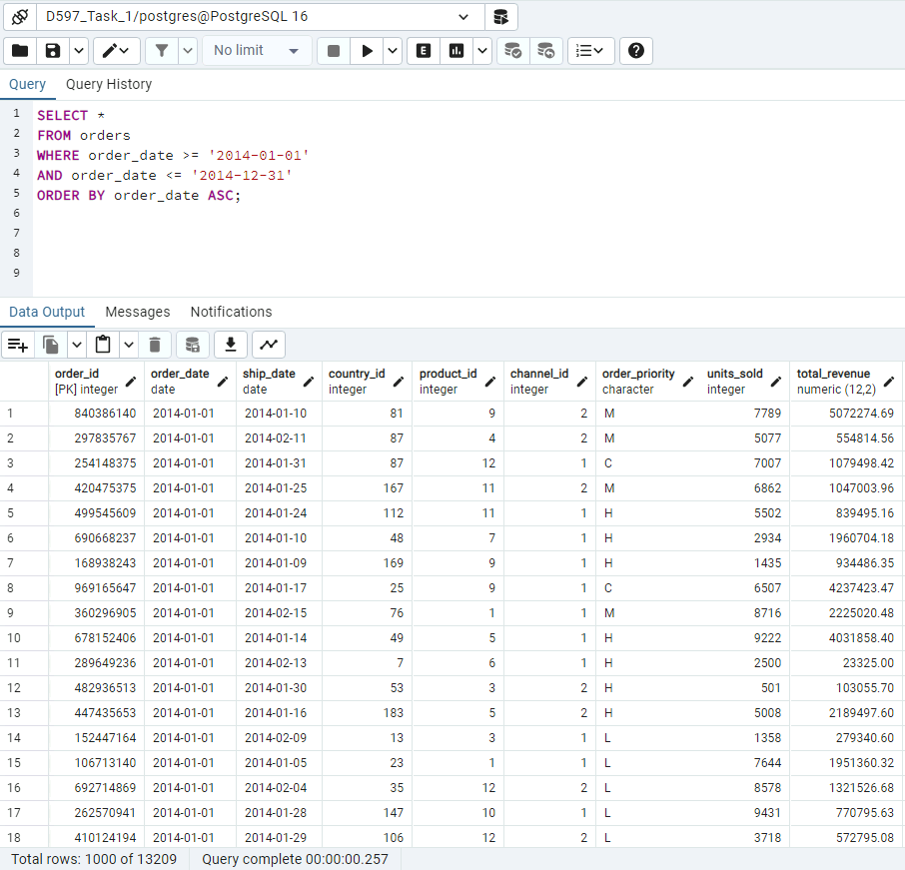

Example 3:
Script 3 (run time on bottom screenshot) | 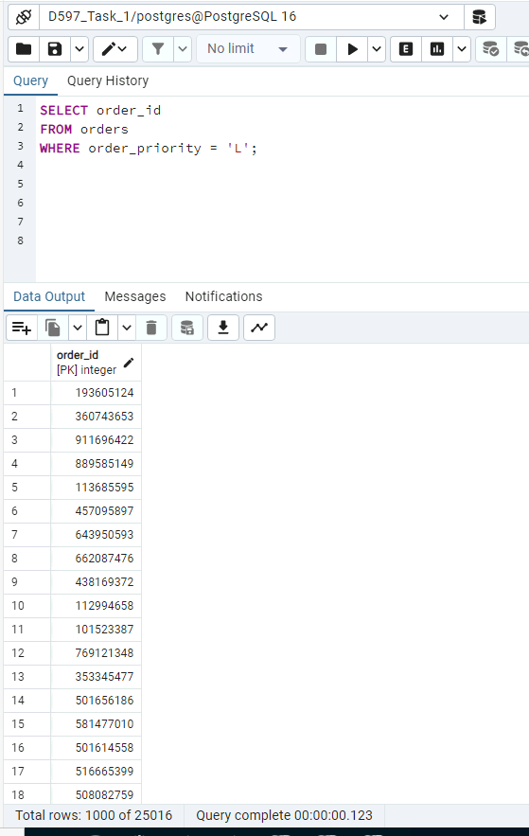
Script 3 Index | 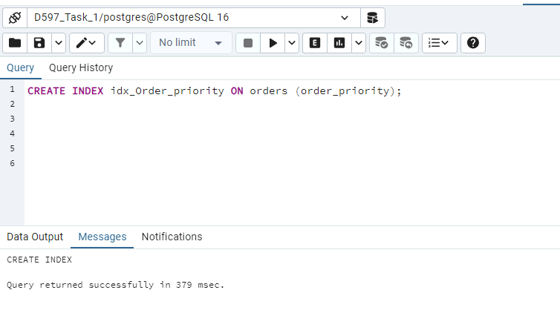
Script 3 with optimization (run time on bottom screenshot) | 